LABORATORIO ARTIGIANO RETI
di ARCHETTI CARLO
Reti da Pesca – Sport – Caccia
Recinzione Impianti Sportivi
Antinfortunistica – Acquacoltura
25058 SULZANO (BS) – Via Tassano, n. 8
Tel. e Fax 030/985290 – Tel. Ab. 030/985191
Cell. 328 0562071 c.f. RCHCRL64C01F532U – P.I. 03216410179
www.retiarchetti.it – info@retiarchetti.it
www.retiarchetti.com – info@retiarchetti.com
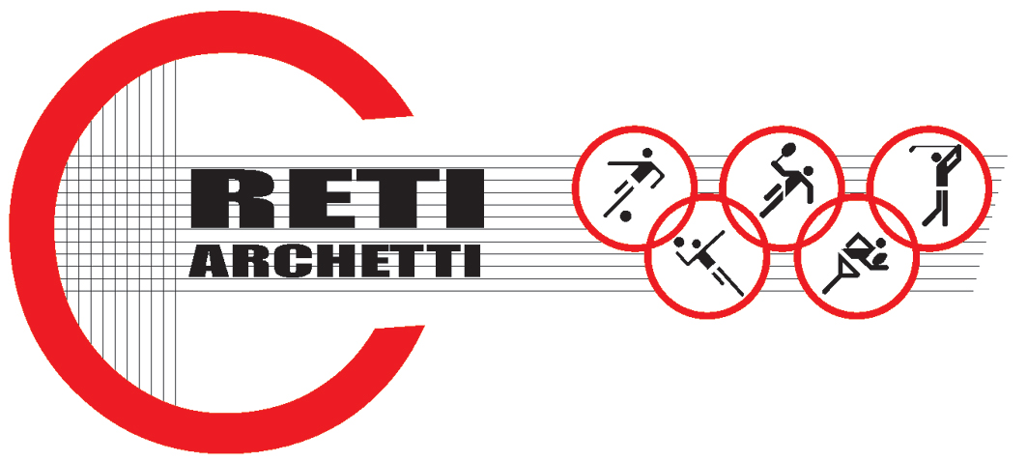

Page n. 1
TECHNICAL DATA SHEET ART.CODE: A 28

NET MADE OF POLYETHYLENE, KNOTTED, STABILIZED AGAINST UV RAYS, MESH mm 20 X 20, THICKNESS mm 1,5

STATIC TESTS: Tests carried out on a polyethylene knotted net, dark green colored (title Pe 3 x 4 x380 denier, mesh mm. 20 x 20).
Equipment used for the test: dynamometer “Acquati model AG 5” with a max. carrying capacity of 5000 daN.
Test carried out on a net with the following features: mg. 23 x mg. 23 and a sphere Ø 220 mm.

Load cell: 5.000 daN
Graphic scale: 40%

RESULTS:

ULTIMATE STRENGTH: 365 daN

Elongation: 35%

Technical features

- MATERIAL: H.D. Polyethylene, stabilized against UV rays, water repellent.
- AVAILABLE COLORS: green or black
- YARN THICKNESS: 1,5 mm.
- NET: squared mesh
- MESH: mm. 20 x 20
- WEIGHT: g. 95/Sq m
- EDGE STRIP: with a 6 mm polyethylene braid
- FUSION TEMPERATURE: 120° C
- MIN. USE TEMPERATURE: – 40° C
- WATER ABSORPTION: 0,01% - WATER REPELLENT –

Pag. n. 2

- MOTH RESISTANCE = ABSOLUTE
- MOULD RESISTANCE = ABSOLUTE
- ABRASION RESISTANCE = EXCELLENT
- MINERAL ACIDS = RESISTANT
- ORGANIC ACIDS = RESISTANT
- ALKALI = RESISTANT
- OIL = RESISTANT

Each net can be manufactured with length and width on customer request. Nets are complete with a reinforced strip along the edge with a 6 mm braid sewed to the net. A piece of rope at the angles makes the installation easier.

